Reward Charts: Making Them Work for You
– A Guide for Parents

The keys issues when making a reward chart:
- The goal needs to be clear
- The times it applies to need to be achievable
- The percentage of time when the goals are kept need to be realistic
- The motivation (reward) needs to be right
- There should be no punishments for missing targets
- If it’s not working, then stop
- Most importantly – the rewards need to be given when agreed

1. The Goal Needs to be Clear
Choose the behaviour you want to change or encourage. When you’ve decided on the behaviour, it’s important to use clear and positive descriptions of the behaviour. For example, ‘Pick everything up off your bedroom floor’ is clearer and easier for your child to understand than ‘Tidy your bedroom’. And ‘Use a quiet voice in the house’ is more positive than ‘Don’t shout’.

If the area you would like to improve on is quite large, it’s a good idea to start small and build upon the positives. For example, if you want your child to keep a main room tidy, then you could start by rewarding them for picking up the Lego every night. Then it could be the Lego and the books, and so on.

Examples of clear, specific targets:
- Clean my teeth before I go to bed
- Come for my tea the first time I am asked
- Tidy away my toys in the living room when I am asked
- Put my dirty clothes in the washing basket when I take them off
- Make my bed every morning as soon as I get up

Examples of poor, confusing targets:
- Be good
- Behave myself
- Don’t be naughty
- Be nice to my sister
- Be tidy
- Be kind

2. The Times it Applies to Need to Be Achievable
Most children enjoy collecting stickers or tokens at the start. But the novelty can wear off quite quickly, and the real reward can seem too far away. So it’s good to choose short-term rewards that you can give often if your child earns them. For example, five stickers will wine a family bike ride, special time with mum or dad, the chance to stay up late, a movie night, choosing what’s for tea etc.
Similarly, the time between stickers/smiley faces needs to be short, especially in the first instance. Ten minutes between stickers etc is fine for a starting point.

Alternatively, rather than rewarding for a period of time where the desired behaviour is displayed, you could reward every time the behaviour is displayed.

For example, if the desired behaviour is ‘Tell Mum or Dad when <<younger sibling>> upsets you’ (rather than lashing out physically) you could either:
- give a sticker for every time period (ie ten minutes) when there has been no lashing out (even there hasn’t been any squabbles), or,
- give a sticker every time there is a squabble but your child comes to you for help rather than lashing out

3. The Percentage of Time When the Goals Are Kept Need to Be Realistic
Allow some space in the chart for failure without it ruining all chance of success as that would be extremely demotivating.

For example, if you have said that your child needs five stickers for a treat, then make sure that there is chance within the day to earn at least seven, then, if there is a set back and they miss out on a sticker, they will still try for the rest of the day.

4. The Motivation (Reward) Needs to Be Right
It is a good idea to set the reward alongside the child to ensure that it is a valued activity. For example, you might think that going for a family bike ride might be fun, but your child might actually prefer to play a board game with you.

Your child might get bored with the same reward. To avoid this, you could work together to set up a reward ‘menu’ with a choice of rewards to spend his stickers on. For example, 5 stickers = a game with mum or extra time before lights out, 10 stickers = choice of a downloaded movie or ice cream with sprinkles and sauce and sweets after tea.

Rewards tend not to be effective if your child can get them in other ways. For example, rewarding them with a bubble bath won’t work so well if they usually have a bath before bed anyway.

5. There Should Be No Punishments for Missing Targets
Missing the reward will be disappointing enough for them. If that happens, then move on and start afresh. If your child is consistently missing targets, then the targets are too challenging for them. If they cannot last an hour without physically lashing out at a sibling, then make the desired time period shorter, maybe even as short as ten minutes just so that they experience some success. You can make it longer the next go around.

Reward charts are supposed to be a positive experience, so don’t be tempted to use it in a negative manner. Don’t remove a sticker once it has been awarded and don’t threaten to boycott giving stickers away. If things are getting tricky, focus on encouraging your child to try again.

6. If It’s Not Working, Then Stop
If your child isn’t motivated by the reward chart, or they are unable to meet even short time periods then stop. Don’t carry on with something which is demotivating to all involved.

7. Most Importantly – The Rewards Need to Be Given When Agreed
If you agree that your child can have a bike ride, bake a cake, stay up late, play a game with you etc if they get five stickers, then you must honour that. Even if something crops up in your day, even if they do something else which is undesirable. If you have promised a treat for five stickers then you must deliver, otherwise they will find it very difficult to trust you in future reward chart scenarios.

Older Children

Children in upper Key Stage Two may not find reward charts as motivating as younger children do, but they can be adapted to work well. Getting the child heavily involved in the design of the chart, the desired behaviours and the rewards is one way to do this.

Link to Pocket Money
If you give your child pocket money, consider linking it to the desired behaviour. For example, if you want your child to keep their bedroom tidy, then:

- Draw up a list of what you consider that to entail, something like this:
- All clothes in the cupboard or washing basket
  - No toys on the floor or the bed
  - Magazines in the box
  - Books on the shelf
  - Curtains open
  - Bed made
- Then set a cut off time, say 6pm.
- Add a statement onto the bottom of the ‘Tidy Room’ list like this: “At 6pm every day, Mum or Dad will check my room, and, if everything from my list is done, I will get my pocket money. If I have missed anything, I will miss my pocket money for the day.”
- Adults and the child all sign to say that they agree
- At inspection time, if the list has been completed, then you would give the child one seventh of their weekly pocket money. If their room is tidy every day, then they will still get the full amount.
- At the start, it would be fair to give warnings and a countdown (or an iPad alarm) to ensure the child is aware that inspection time is coming.
- It would also be helpful to limit the number of items on the list and start with a tidy room for day one.
- If the child completes the list, you must give the reward, otherwise they will quickly become demotivated.

Doing School Work

If you are having trouble getting your child to complete their work for school, try this:

- Identify an activity which your child values highly, such as playing on their Play Station, watching TV, playing in the garden etc.
- Write a contract with your child which states that however long they spend on doing their school work, then they will be able to have that time back again in their chosen activity. For example, if they work for an hour, they will get an hour to play football in the back garden.
- They need to notify you when they are starting work and when they are done.
- The work comes first and then, when they are done, they get their reward.
- It’s important to specify what you do and don’t count as work (watching a YouTube video on maths??) and that they must be able to share what they have done once they’re finished.
- Once the contract is written, everyone signs.

Getting Ready on a Morning

If you feel that mornings are just a round of nagging your children to get up, get dressed, get washed etc, try this.

- With your child, draw up a list of ‘Morning Jobs’:
  - Get washed
  - Clean your teeth
  - Get dressed
  - Eat breakfast
  - Put your dishes in the dishwasher
  - Make your bed
- Then, explain that there will be no TV, internet, playing, iPad etc until they have ticked everything off the list.
- Instead of the constant nagging, your child will have their list to work through and show you when they are done. This will increase, not only their independence, but also their self-esteem.

How To Set Up a Chart

You can choose from lots of different styles of charts or make one yourself. Older children might like to create their own chart, perhaps with a drawing or photo of the reward they’re trying to earn.

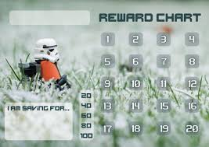

Another option is a reward chart app on your phone. Reward chart apps are portable and let you give your child a star as soon as he earns it, even when you’re out.
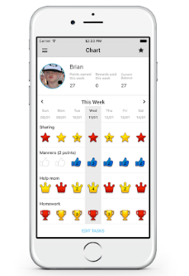

It is a good idea to design your child’s charts and rewards on their age and interests.
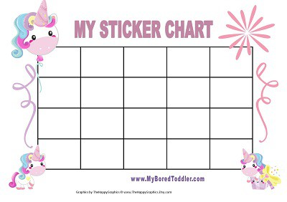
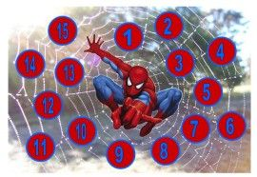

You could use a jigsaw puzzle as your chart and give your child one piece at a time to complete it.
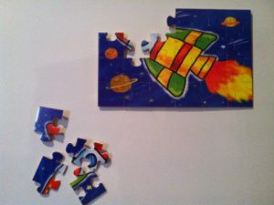

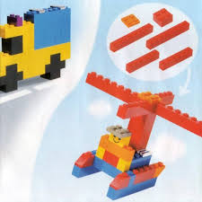
Lego bricks given as part of a larger model can also work well, but only if they are given very regularly.

When you’ve decided on your chart, decide which stickers or tokens to use – star stickers work well for younger children, whereas older children might like points or other markers.

Put the chart where your child would like it. Keep in mind that an older child might prefer a spot that’s private.

Moving on from the reward chart
You can gradually stop using the reward chart once your child’s behaviour has changed. It’s a good idea to keep noticing and praising your child for the behaviour as you phase out the chart. For example, you might gradually phase out a reward chart after a few weeks by increasing the length of time between stickers or points. If your child is getting a sticker each day for unstacking the dishwasher, you could make it a sticker every two days, with praise and hugs as well.

