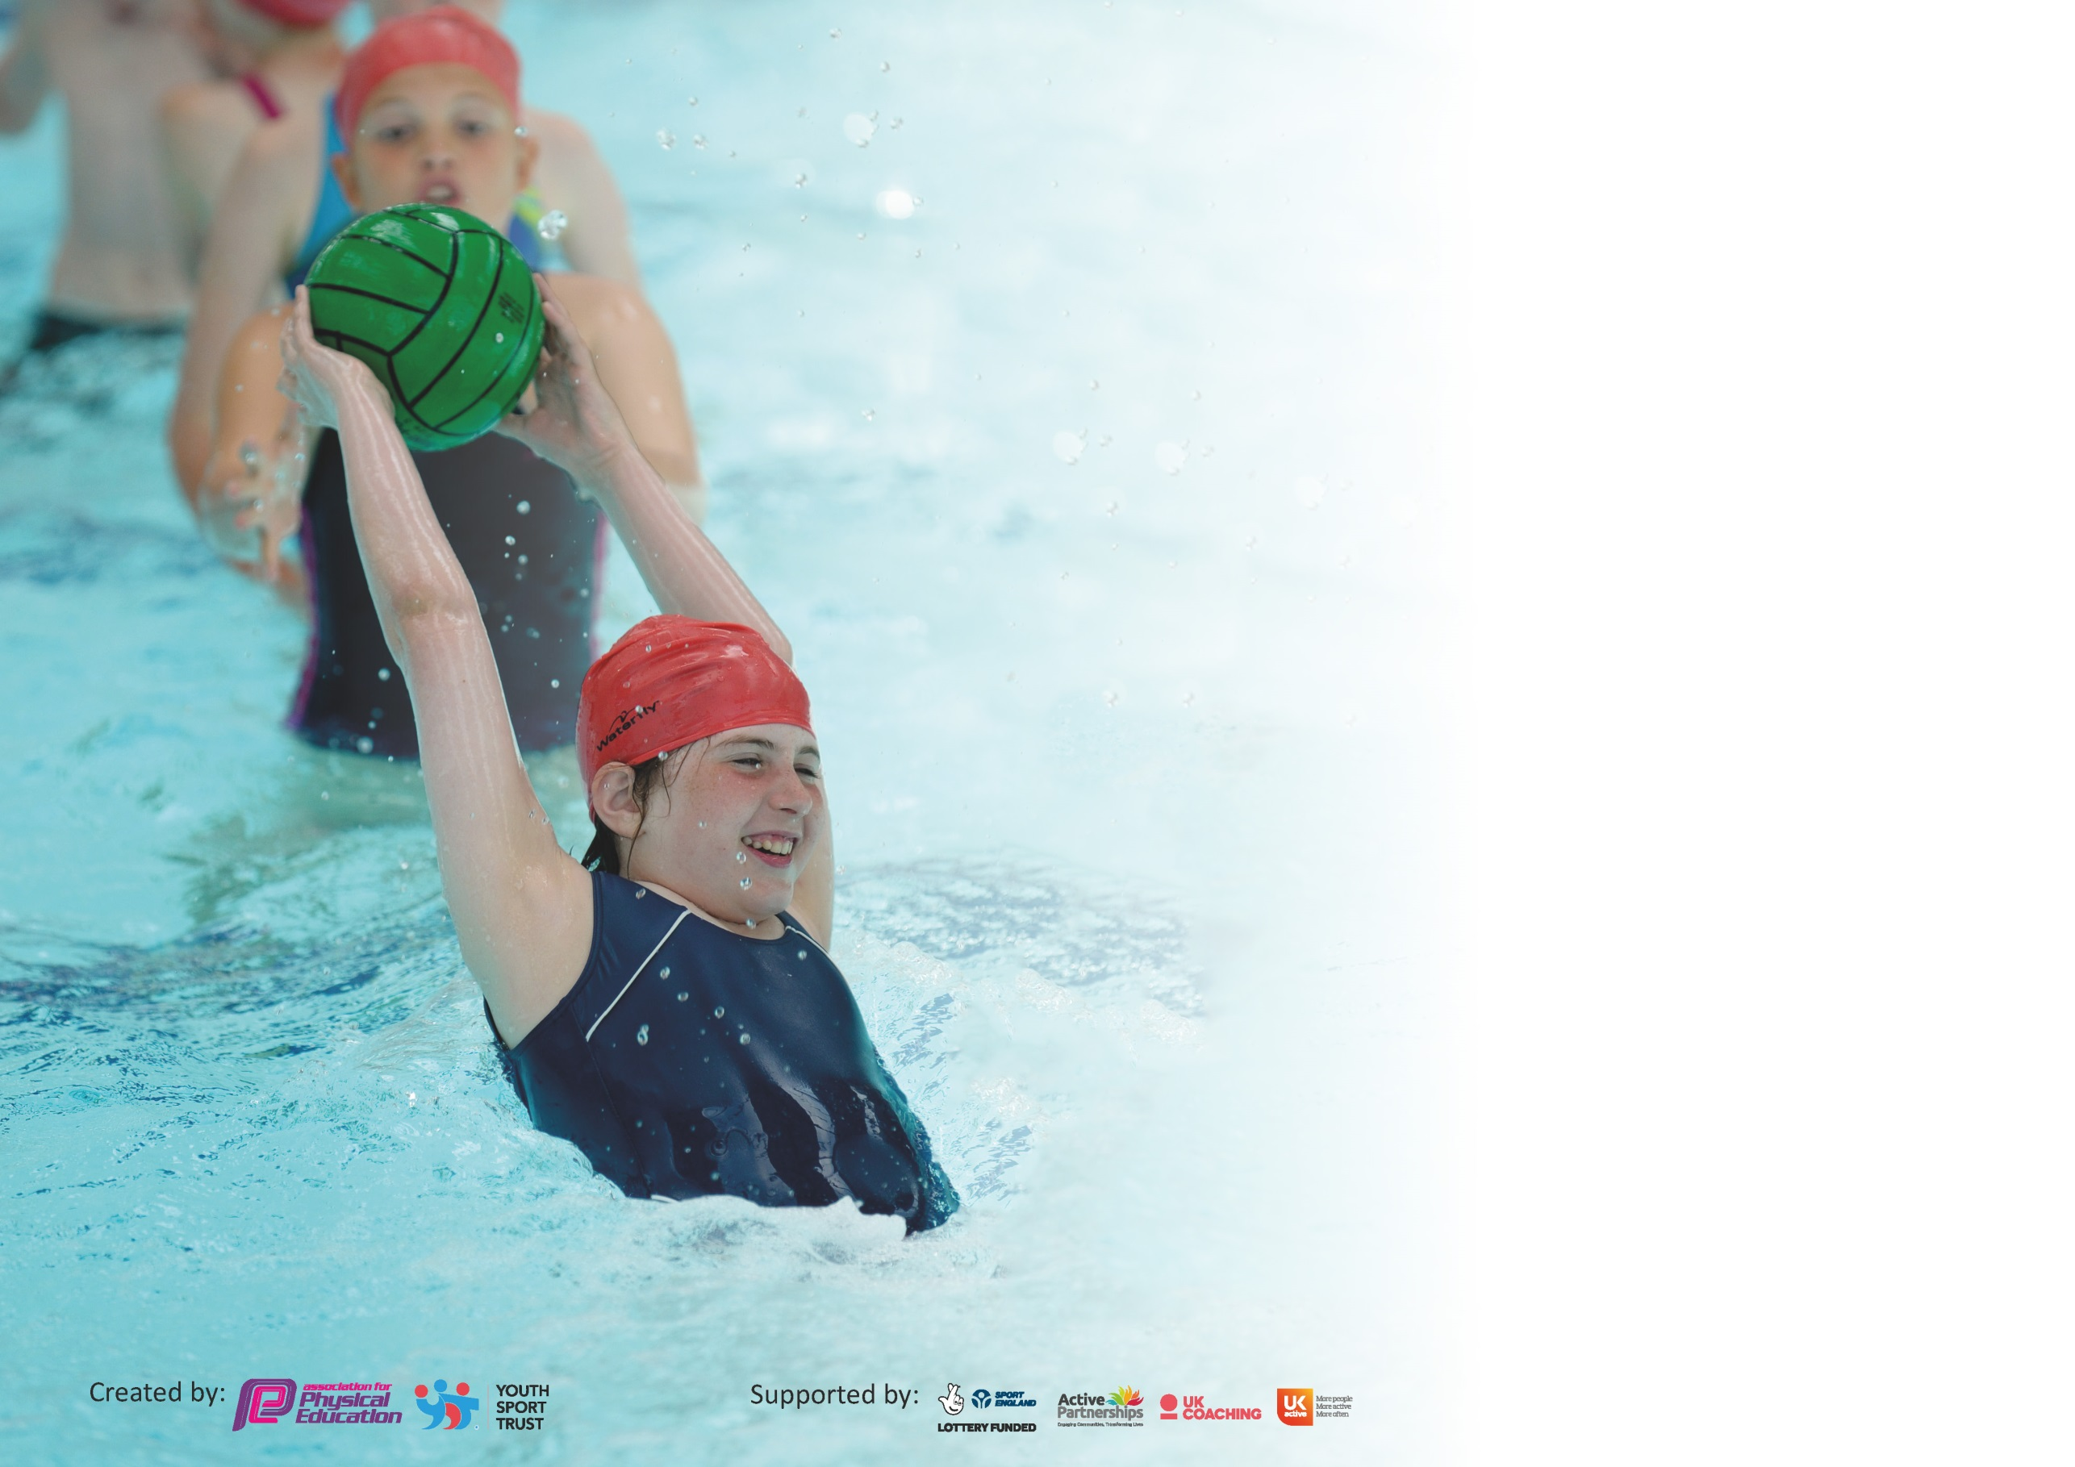

It is important that your grant is used effectively and based on school need. The Education Inspection Framework (Ofsted 2019 p64) makes clear there will be a focus on ‘whether leaders and those responsible for governors all understand their respective roles and perform these in a way that enhances the effectiveness of the school’.

Under the Quality of Education criteria (p41) inspectors consider the extent to which schools can articulate their curriculum (INTENT), construct their curriculum (IMPLEMENTATION) and demonstrate the outcomes which result (IMPACT).

To assist schools with common transferable language this template has been developed to utilise the same three headings which should make your plans easily transferable between working documents.

Schools must use the funding to make additional and sustainable improvements to the quality of Physical Education, School Sport and Physical Activity (PESSPA) they offer. This means that you should
use the Primary PE and Sport Premium to:

- Develop or add to the PESSPA activities that your school already offer
- Build capacity and capability within the school to ensure that improvements made now will benefit pupils joining the school in future years

Please visit gov.uk for the revised DfE guidance including the 5 key indicators across which schools should demonstrate an improvement. This document will help you to review your provision and to report your spend. DfE encourages schools to use this template as an effective way of meeting the reporting requirements of the Primary PE and Sport Premium.

We recommend you start by reflecting on the impact of current provision and reviewing the previous spend.

Schools are required to publish details of how they spend this funding as well as on the impact it has on pupils’ PE and sport participation and attainment by the end of the summer term or by 31st July 2020 at the latest.

We recommend regularly updating the table and publishing it on your website throughout the year. This evidences your ongoing self-evaluation of how you are using the funding to secure maximum, sustainable impact. Final copy must be posted on your website by the end of the academic year and no later than the 31st July 2020. To see an example of how to complete the table please click HERE.

Support for review and reflection - considering the 5 key indicators from DfE, what development needs are a priority for your setting and your pupils now and why? Use the space below to reflect on previous spend and key achievements and areas for development.

Key achievements to date until July 2019: | Areas for further improvement and baseline evidence of need:
- Westgarth has successfully continued the Girls’ Active programme that has helped every girl from Year 1-6 in being more active and given them role models to look up to while helping the actual Girls’ Active girls.  - Westgarth successfully tracked the participation of all the children for what physical activities they did outside the curriculum to see which children were ‘less active’.  - Swimming percentages continued to be high due to the earlier starting point of Year 1 that continues to be successful.  - Westgarth officially bought into a skills-based programme of work ‘Jasmine’ that fits into the school PE ethos and direction.  - PE equipment has increased dramatically which will allow for more range and scope with teachers teaching PE. | - Staff need to buy into the new programme of work and ensure that they use this as CPD as well as a resource so that we higher skilled PE teachers.  - Emotional and mental health will be very important in September and moving forwards. Special care and thought needs to go into next year’s funding.  - Physical fitness levels of the children will have dropped so this will need to be looked at moving into September and moving forwards on how we can close the gap.

Meeting national curriculum requirements for swimming and water safety.
What percentage of your current Year 6 cohort swim competently, confidently and proficiently over a distance of at least 25 metres?  N.B. Even though your pupils may swim in another year please report on their attainment on leaving  primary school at the end of the summer term 2020. | 100%
What percentage of your current Year 6 cohort use a range of strokes effectively [for example, front crawl, backstroke and breaststroke]? | 95.5%
What percentage of your current Year 6 cohort perform safe self-rescue in different water-based situations? | 100%
Schools can choose to use the Primary PE and Sport Premium to provide additional provision for swimming but this must be for activity over and above the national curriculum requirements. Have you used it in this way? | Yes/No

Action Plan and Budget Tracking
Capture your intended annual spend against the 5 key indicators. Clarify the success criteria and evidence of impact that you intend to measure to evaluate for pupils today and for the future.

Academic Year: 2019/20 | Total fund allocated: £18,681 | Date Updated: 24/07/20
Key indicator 1: The engagement of all pupils in regular physical activity – Chief Medical Officer guidelines recommend that primary school pupils undertake at least 30 minutes of physical activity a day in school |  |  |  | Percentage of total allocation:
 |  |  |  | %
Intent | Implementation |  | Impact | £1,489
Your school focus should be clear what you want the pupils to know and be able to do and about  what they need to learn and to  consolidate through practice: | Make sure your actions to achieve are linked to your intentions: | Funding allocated: | Evidence of impact: what do pupils now know and what can they now do? What has changed?: | Sustainability and suggested next steps:
1a. To increase engagement of children in physical education.  1b. To upskill children in Upper Key Stage 2 to make themselves more active and also younger children.  1c. To increase the ‘active’ minutes used in play times and PE lessons.  1d. To increase the numbers joining in PE on a regular basis. | 1a. Daily Mile- Children to run for around 10 minutes each day around the flagged track on the field/designated playground.  1b. Training of ‘new’ playground monitors to support playground games.  1c. Purchase of equipment to support active lessons and PE lessons.  1d. Purchase of green shorts for every year group to have clean spare kit for children to join in. | 1.a £0  1.b £0  1.c £1,309  £180 | 1a. Increased level of children getting their 30 minutes + of active minutes.  1b. Increased uptake on Westgarth friends and engagement with younger children during playtimes.  1c. Further engagement in lessons with staff being able to offer more chances to be active in lessons.  1d. Increased participation in PE lesson for more vulnerable groups and teachers feel more confident to get everyone in their lesson ready learn. | To build on more ways that staff can involve active lessons and chances to give children more chance to be active.  To continue to include all children in PE and Sports throughout the school year.
Key indicator 2: The profile of PESSPA being raised across the school as a tool for whole school improvement |  |  |  | Percentage of total allocation:
 |  |  |  | %
Intent | Implementation |  | Impact | £122
Your school focus should be clear what you want the pupils to know and be able to do and about  what they need to learn and to  consolidate through practice: | Make sure your actions to achieve are linked to your intentions: | Funding allocated: | Evidence of impact: what do pupils now know and what can they now do? What has changed?: | Sustainability and suggested next steps:
2a. Year 6 children to be upskilled and to work with younger girls to inspire and grow on personal skills.  2b. To increase awareness of what physical education and sport that is happening at Westgarth.  2c. To promote the sporting success and participation in school.  2d. To build up leadership and the profile of the importance of PE in school. | 2a. Girls’ Active to work with Year 2, 3, 4, 5 and 6 one afternoon a week. Each year group gets a half term.  2b. Children and staff are trained to tweet, blog and report on sporting activities in school.  2c. Celebration assembly every week, to ensure the whole school is aware of the importance of PE and sport.  2d. Sports Leader training. | 2a. £0  2b. £0  2c. £122  2d. £0 | 2a. Year 1, 2, 3, 4, and 6 girls all increased their active minutes for a half term each, once a week and reported that they were inspired to be part of the team when they get to Year 6.  2b. Increased the content that is being shared through social media, the website and the Westgarth Weekly.  2c. It has continued to grow the enthusiasm of what the children at Westgarth are achieving.  2d. All Year 6 children to do the Sports Leader training. | To continue to train girls that are in Year 6 to work with other girls in Westgarth.  Boys mentioned the desire to have a boys active so this will be explored also.

Key indicator 3: Increased confidence, knowledge and skills of all staff in teaching PE and sport |  |  |  | Percentage of total allocation:
 |  |  |  | %
Intent | Implementation |  | Impact | £8,443
Your school focus should be clear | Make sure your actions to | Funding | Evidence of impact: what do | Sustainability and suggested
what you want the pupils to know | achieve are linked to your | allocated: | pupils now know and what | next steps:
and be able to do and about | intentions: |  | can they now do? What has
what they need to learn and to |  |  | changed?:
consolidate through practice:
3a. To increase the staff’s understanding of its use and delivery.  3b. To upskill the staff on how to deliver different aspects of PE.  3c. To upskill staff on delivering PE in different year groups with team teaching.  3d. To upskill certain members of staff.  3e. To introduce a skill-based PE curriculum and to give some context to teach it through the school.  3f. To make teachers more confident with the curriculum. | 3a. Super movers- Staff to be trained on how to use it.  3b. CPD- Release time for staff to train, team-teach, observe and be observed.  3c. Continuous professional development program for teaching staff delivered by a specialist PE teacher (Mr Buckby) delivered to each year group within school.  3d. CPD on training for staff.  3e. Staff meeting with Ryan from the FA.  3f. Buy into a programme of work to help guide teachers through the teaching PE and ensure skill progression. | 3a. £0  3.b £500  3.c £4,663  3d. £0  3e. 0  3f. 3,280 | 3a. Some staff are using Supermovers to help with general teaching.  3b. Staff feel more confident on certain aspects of the PE curriculum.  3c. Staff feel more confident on certain aspects of the PE curriculum especially the ones that moved year groups.  3d. Numerous aspects of PE upskilled in key areas of the school.  3e. Very positive feedback from the teachers and a shift move from teaching sports to skills that can be applied across any sport.  3f. Bought in July ready to go for September. | To upskill teachers on dance, delivering a skills-based curriculum and how teachers can make the children more active throughout the school day.
Key indicator 4: Broader experience of a range of sports and activities offered to all pupils |  |  |  | Percentage of total allocation:
 |  |  |  | %
Intent | Implementation |  | Impact | £5,727
Your school focus should be clear | Make sure your actions to | Funding | Evidence of impact: what do | Sustainability and suggested
what you want the pupils to know | achieve are linked to your | allocated: | pupils now know and what | next steps:
and be able to do and about | intentions: |  | can they now do? What has
what they need to learn and to |  |  | changed?:
consolidate through practice:
4a. To help offer a chance to children to experience a range of PE and sports.  4b. To increase the experience of children joining in with different sports.  4c. To train the staff to offer the range of sports for the children.  4d. To increase inside and outside participation in cricket.  4e. To offer more year groups a wider and specialised experience. | 4a. Continue to offer wider range of activities:  -Yoga  -Dance Magic  -Destination Judo  -Team Soccer 442  -School Sports Partnership  -Yoga Bugs  4b. Staff to run activities/lessons  -Football  -Rugby  -Cycling/Bike Ability  -Golf  -Running  4c. Training Golf, OAA and cricket.  4d. Bought into the cricket association specialist coaching.  4e. Sports specialised teacher. | 4a. £2,490  4b. £0  4c. £0  4d. £150  3.d £3,087 | 4a. Children’s social interaction and calmness has increased and incidents at play and dinner times.  4b. Increased number of after school clubs and participation.  4c. Staff have done more PE based clubs due to upskilling.  4d. More children understand the sport/game of cricket and tried out for the local cricket club.  4e. Greater importance has been put on PE at Westgarth. | To continue to build on the broad range of sports and activities.  Bring in a boxercise company and buy resources for long-term sustainability. Didn’t happen due to coronavirus.

Key indicator 5: Increased participation in competitive sport |  |  |  | Percentage of total allocation:
 |  |  |  | %
Intent | Implementation |  | Impact | £ 2,850
Your school focus should be clear | Make sure your actions to | Funding | Evidence of impact: what do | Sustainability and suggested
what you want the pupils to know | achieve are linked to your | allocated: | pupils now know and what | next steps:
and be able to do and about | intentions: |  | can they now do? What has
what they need to learn and to |  |  | changed?:
consolidate through practice:
5a. To increase the participation and inclusion of all children in the school.  5b. To increase the participation and inclusion of all children in the school.  5c. To increase participation of competitive fairly. | 5a. School Games Day  5b. Inter school festivals and fixtures for a range of sports and enter as many children as possible.  5c. Use a database to track children’s participation throughout the year to identify gaps. | 5a. £50  5b. £2,800 | Didn’t happen due to coronavirus.  5b. Increased number of children joining in participation against other schools.  5c. Successfully tracked throughout the year and gaps identified. | To continue to buy into the Sports Partnership to ensure that children compete and to give intra school a continued focus.  Use the database to target children moving into their next year group.

Signed off by
Head Teacher: | J. Woodhead
Date: | 17/07/2020
Subject Leader: | Andrew Duncan
Date: | 11/07/2020
Governor: | Ruth Bolton
Date: | 24/07/2020

