Westgarth Primary School 01642 485560
Redcar Road www.westgarthprimaryschool.co.uk
Marske-by-the-Sea westgarthoffice@westgarth.rac.sch.uk
TS11 6AE Tweet: @westgarthSchool
Friday 1st May 2020
Dear Families,

A warm welcome to the month of May!
School Closure Update
In the Prime Minister’s press conference last night, there was clear reference to an announcement about the strategy for re-opening schools being made at next week’s review. Please be aware that school leaders hear any announcements at exactly the same time as you, so we will communicate with you as soon as we are able.
Technical Support
Don’t forget that the ever patient Mr Knott is at hand for support with any technical problems you encounter with Abacus or Reading Buddy. Just email onlineaccounts@westgarth.rac.sch.uk
A huge thank you and well done
Class teachers have asked me to pass on a huge thank you for the care and compassion you have shown towards them and their families in emails, messages and phone calls. We have really valued speaking with parents and carers and we think you are all doing a great job in such difficult circumstances. We know that parenting does not come with a manual, and children never follow textbook patterns or rules. Many of you are juggling key working, home working, a lack of outdoor space, financial pressures and a loss of links and support from extended family and friends. And then, attempting home schooling on top …..
Throughout lockdown, I have been attending Zoom and Skype meetings with a wide range of professionals: teachers, Headteachers, social workers, health visitors, IT technicians, engineers, even the Department for Education. All of those calls have been characterised by the same things: slightly dishevelled, wide-eyed adults; and background images of small children spinning round and round, teenagers sloping about in their pyjamas and very needy cats and dogs! As adults, we are certainly all in this together, and will never want to hear the words “I’m hungry” at all hours of the day and night again!
And finally…
We thought you might enjoy reading this tweet about home schooling both a 9 and 16 year old child under lockdown written by an ex OFSTED Inspector. Apparently, he has proudly displayed his OFSTED rating in his front window!

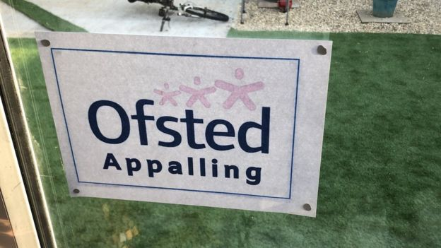

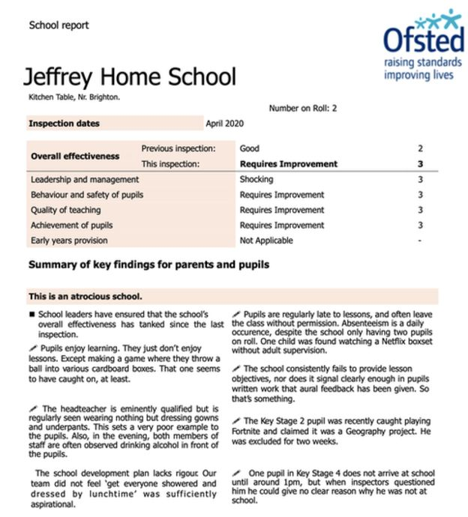

With our very best wishes to you all. Stay safe and keep smiling!
Yours sincerely,
Mrs J Woodhead
Headteacher

